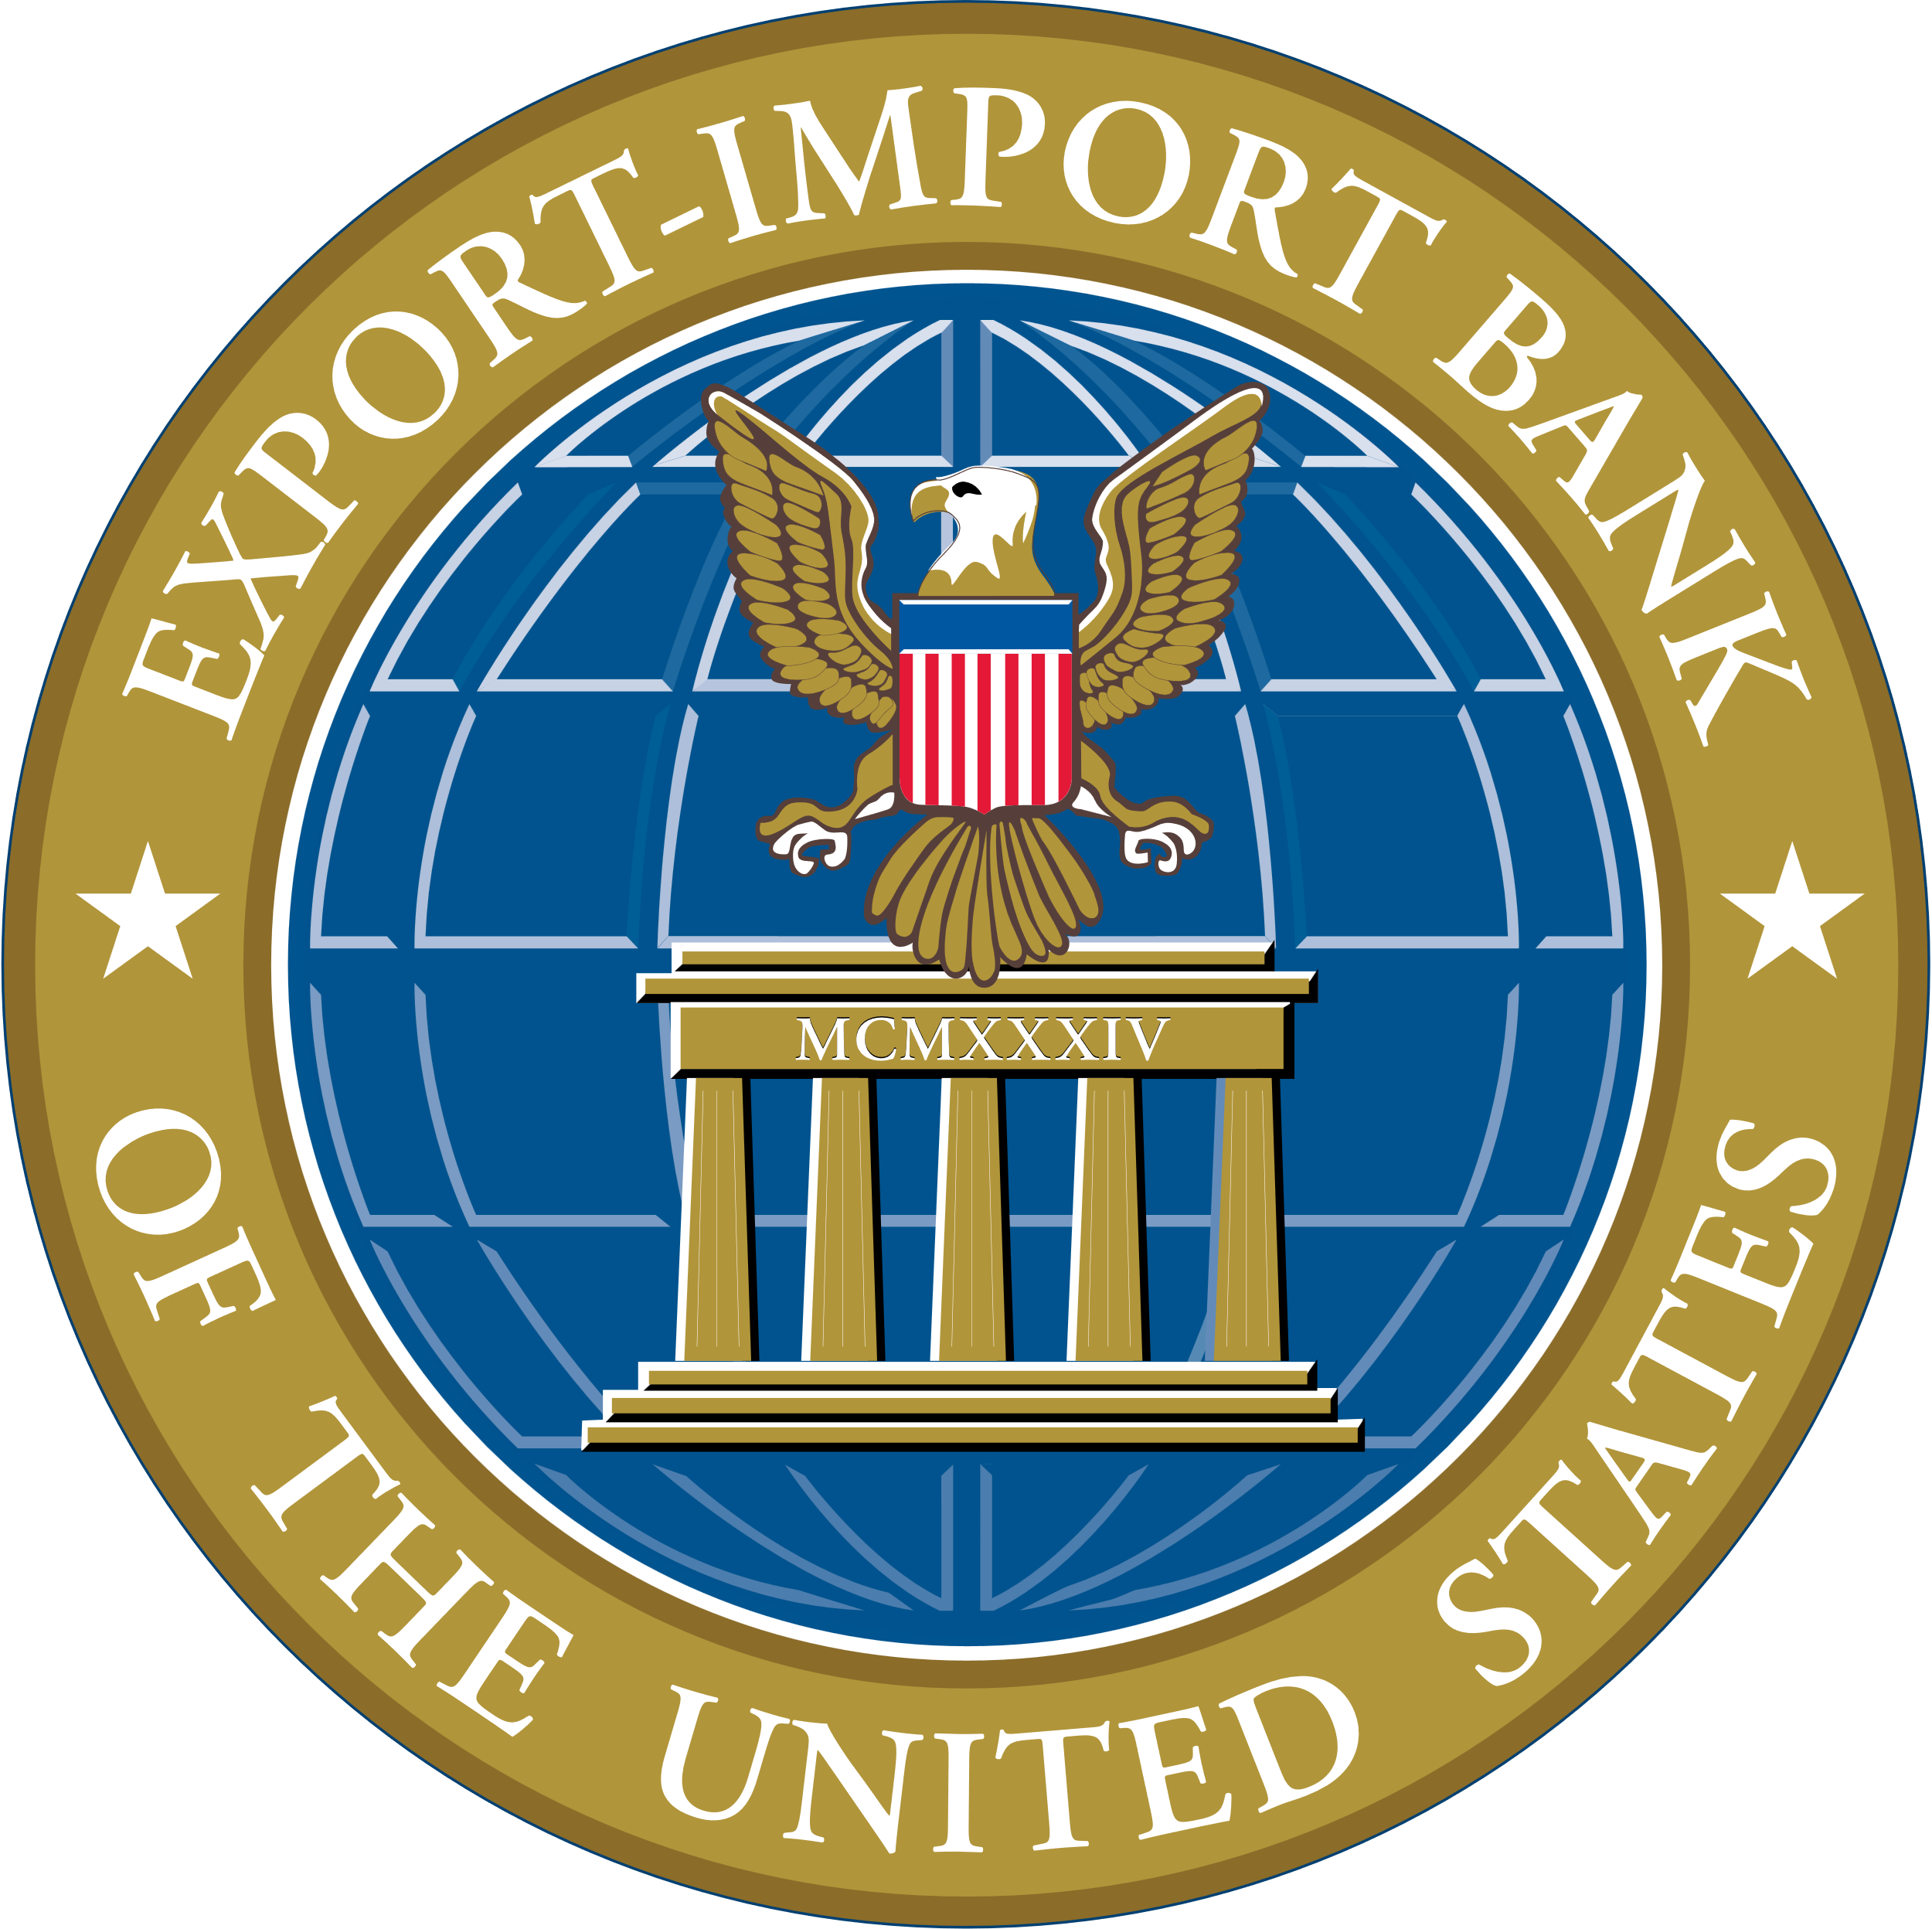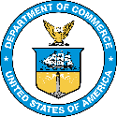

CULTIVA Global Solutions & The Atlas Initiative

Resilience Strategies for a Sustainable Tomorrow

* Proven track record
* Customized solution oﬀerings
* Global network
* Multidisciplinary expert team
* Strategic partnership ecosystem
* Scope-specific pricing
* Modularized support
* Cutting-edge data analytics
* Results-oriented

Atlas is the partner organization of the World Federation of Engineering Organizations.

Our team leverages partnerships with national engineering societies worldwide.

* **NAICS Codes**
* 541611
* 541612
* 541618
* 541620
* 541690
* 541990

**Certiﬁed:** Small Disadvantaged Business and HUBZone

**UEI:** X1M5Z62MEM X9

**GSA MAS:** 47QRAA22D0005

**HQ Address:** 1255 Union St NE, 7th Floor,

Washington, DC 20002

**Website:** globalcultiva.com

* Advanced Data Analysis
* Stakeholder Engagement Platforms
* Strategic Advisory Services
* Policy Development and Implementation
* Standard and Procedure Adoption Services
* Capacity Building with Training, Technical Assistance, and Mentoring
* Enabling Relevant Procurement Practices and Market Capacity
* Fostering Collaboration Between Public and Private Sector Organizations

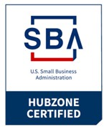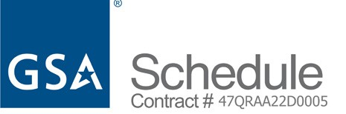

**DUNS:** 74XC7 **| CAGE Code:** 036755629

A HUBZone Small Business & Resilient Infrastructure Experts

Team Capability Statement

**CERTIFICATIONS**

**DIFFERENTIATORS**

**PAST PERFORMANCE**

**Core Capabilities**

**Cultiva Global Solutions** is a premier federal government contractor dedicated to solving international and domestic economic challenges and promoting equitable prosperity. Our focus on safety, health, and environmental sustainability has earned us a reputation for outstanding client satisfaction and project success. Our extensive global network of elite, vetted partners allow us to deliver a wide range of tailored solutions to meet the diverse needs of our clients.

**The Atlas Initiative** delivers innovative sustainable infrastructure solutions through existing partnerships with national engineering societies across the globe to promote economic development, disaster resilience, health and safety for communities and vulnerable populations.

**EXECUTIVE SUMMARY**